Title(Bold）
First Author ^{A}, Second Author ^{A,B}, and Last Author ^{C}
Affiliation1 ^{A)}, Affiliation2 ^{B)}, Affiliation3 ^{C)}

This is the template of abstract for the symposium on Extended Molecular Dynamics and Enhanced Sampling: Nosé Dynamics 30 Years (NOSE30). Presentation Number, shown in header, will be assigned by the organizers. The length of abstract for all type of presentation (Invited or Poster) is within 1 page. As for font, the title of the abstract should be in Times Roman 14pt Bold, and the other should be in Times Roman 12pt. The affiliations should be in Italic. Text decollations (bold, italic, underline etc..) can be available for highlight or emphasis in the body. As for equation, you can use MSWord object (MS math3.0 etc.) or past image files directly. The sample of the MS math3.0 is as follows:
On the other hand, the example of the image file, which is generated by LaTeX and is cut from outputted PDF, is as follows:
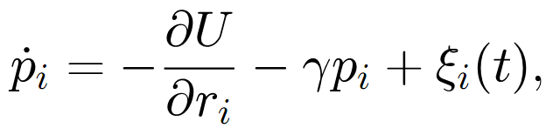
Please adjust the suitable size so as to identify the suffix of equation. To be better quality figure, we recommend making relatively larger image for equations or figures and shrink them on the MS Word template.
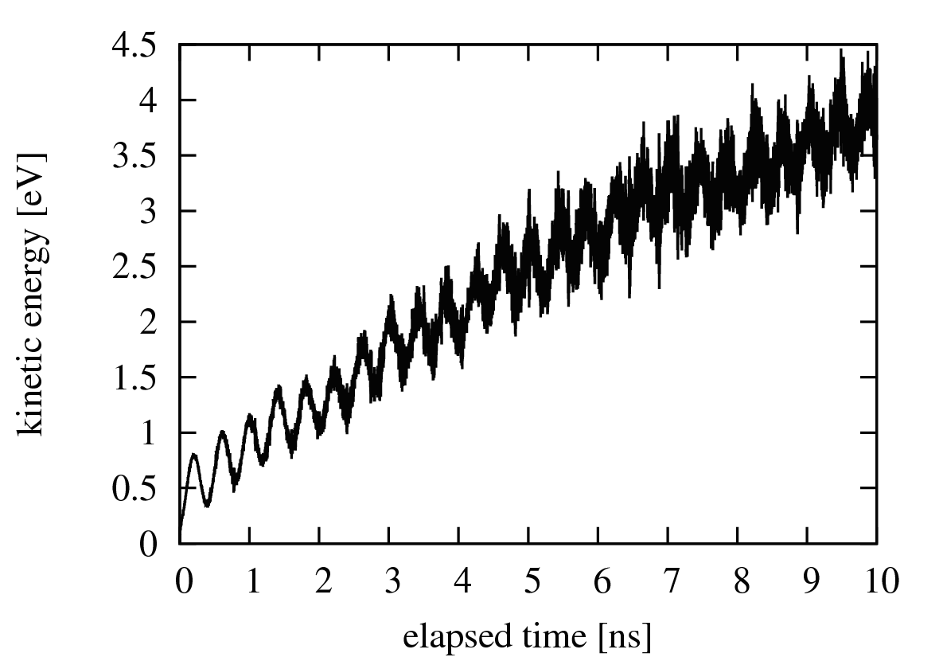
Figure1: Explanation of Figures. Font is in Times Roman 11pt.
- B. J. Alder and T. E. Wainwright, J. Chem. Phys. 127, 1207 (1957).
- B. J. Alder and T. E. Wainwright, Phys. Rev. A, 1, 18 (1970).

